Countdown to success

Supplier Summit and STEM Experience

The Bridge to Local, State, and Federal Opportunities

EXHIBITOR REGISTRATION
Event Date: Wednesday, March 25, 2020
Exhibitor Form and fees must be received no later than March 1, 2020

Company Name | Contact Name | Supplier Summit | STEM Experience
Company Website | Email Address | Phone

Event Location: Trident Technical College, North Charleston, SC
Exhibitor Benefits Include:
- Booth 10 feet X 10 feet | - One six-foot draped table
- Two folding chairs | - Wi-Fi access
- Access to electricity | - Trash can

Exhibitor Costs: (Please fill in number of booths and electrical, if required)
Booth: $250 per 10 foot X 10 foot space
I need _____ booth space(s) at $250 each: Total: $_______
Reminders:
- I completed form and saved a copy for my records.
- I enclosed a check made out to Charleston County Government with ”Countdown to Success” noted in the check’s memo.
- Please send form and payment to: Charleston County Government, Countdown to Success,
4045 Bridge View Dr., Suite B-252, N. Charleston, SC 29405
- Questions? Please contact Kevin Limehouse at klimehouse@charlestoncounty.org or 843.958.4012. Go to charlestoncounty.org/nasa.php for more information.
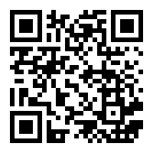
Thank you for participating as an exhibitor at the Countdown to Success: Supplier Summit and Stem Experience.

